**Standard Procedures for 31P Magnetic Resonance Spectroscopy Studies Involving Isometric or Dynamic Contractions of the Thigh Muscles**

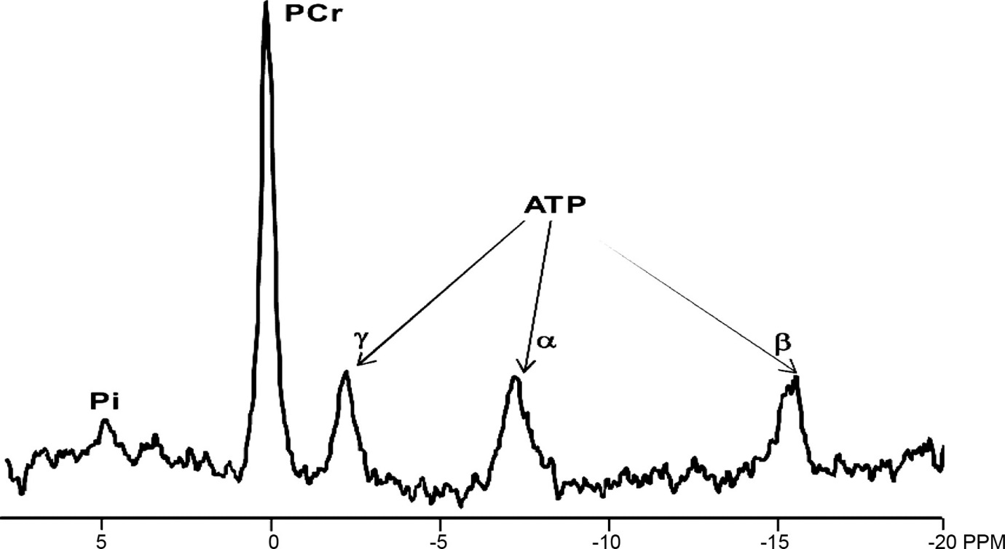

GENERAL NOTES

* Add captions to figures
* Make sure pictures are all in focus
* Use single pictures that show entire set up instead of multiple pictures that show only parts of set up…one picture gives much better visual perspective and shows reader how parts fit together
* For brevity, many explanations of why a step is included are not necessary. When they are, I suggest using secondary NOTE bullets to clean up steps but also retain details
* Overall, most of steps can be significantly condensed especially by combing steps
* Use a different color than red for researcher 2 so warnings will stand out
* I don’t know if it’s necessary to specify researcher 1 or 2 for every task, especially for prep when it’s all a one person job anyways

It would be valuable to have set up pictures that included a person as a subject **OVERVIEW:**

This manual describes the general steps needed to prepare for 31P Magnetic Resonance Spectroscopy studies involving isometric or dynamic contractions of the thigh muscles. It has been broken down into two sections, Habituation/Contraction Practice and MRS Data Collection.

**Table of Contents:**

1. **Habituation/Contraction Practice 3** 
   1. **Setup prior to subject arrival 3**
   2. **After subject arrival 11**
   3. **Contraction Practice 14**
2. **MRS data collection 16**
   1. **Setup prior to arrival at the magnet 16**
   2. **Setup at the magnet 16**
   3. **Subject positioning 19**
   4. **Force verification 19**
   5. **Coil position verification 20**
   6. **Exercise protocol 20**
   7. **Subject exit 21**
   8. **After subject exit 21**
3. **Habituation/Contraction Practice:**

**Location:** Contraction practice sessions are held in the VUIIS building, room AA0112.

**A. Setup prior to subject arrival:**

1. Researcher 1 will place the ‘Research in Progress’ sign on door.

|  |  |
| --- | --- |
|  |  |

1. Researcher 1 will roll the MR patient table to the center of the open floor space.
   1. ***NOTE:*** Space should be left available to open the door, access the table and chairs, and also access the scale.
2. Researcher 1 will lock all four table wheels. [Prevents table from rolling during subject mount/dismount and during all contraction protocols.]

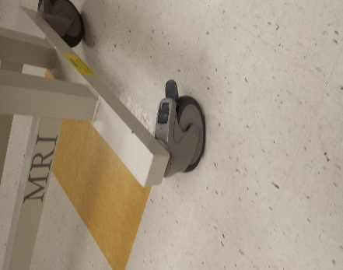

Unlocked

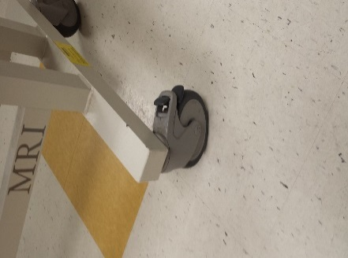

Locked

1. Researcher 1 will slide subject straps and buckles on to the MR patient table towards the exercise device half of the table.
   1. ***NOTE:*** Alternate sides for buckles and straps and be sure to insert the straps with the Velcro side up to facilitate strap tightening and closure. These straps are intended to secure the subject’s hips and thighs.

|  |  |
| --- | --- |
|  |  |

1. Researcher 1 will secure the patient bed to the rolling table using two ratchet straps. Straps should be pulled inside the axial table arms. The strap most proximal to the exercise device should go across the table immediately forward of the grid plate. Cinch the straps down as tightly as possible.

|  |  |
| --- | --- |
|  |  |
|  |  |

1. Researcher 1 will place the thigh exercise device in a central position on the MR patient bed grid plate as shown in the photos below. [Assures that the anatomical region of interest on the subject will be in the center of the short axis of the magnet bore, and that their foot will have sufficient space to avoid contacting the bed during dynamic thigh muscle contractions.]

|  |  |
| --- | --- |
|  |  |

1. Researcher 1 will affix the thigh exercise device to the MR patient table using the four MR compatible screws and the hex wrench.
   1. ***NOTE***: The hex wrench is non MR compatible..

|  |  |
| --- | --- |
|  |  |

1. Researcher 1 will place the gray coil pad immediately in front of the grid plate with lowered section at grid plate end. The precise position of this pad will be adjusted later based on patient characteristics.

|  |  |
| --- | --- |
|  |  |

1. Researcher 1 will place the smaller thick table pad in front of the gray coil pad.

|  |  |
| --- | --- |
|  |  |

1. Researcher 1 will place larger thick pad in front of larger pad.

|  |  |
| --- | --- |
|  |  |

1. Researcher 1 will place the pad for the non-exercising foot as shown in the photo.

|  |  |
| --- | --- |
|  |  |

1. Researcher 1 will cover table pads with a hospital bed sheet. Fold the sheet along the long axis and tuck each side under the pads. Fold a pillowcase and place it inside the non-exercising footpad.

|  |  |
| --- | --- |
|  |  |

1. Researcher 1 will place the foot pad inside the base of the exercise device. Fold the larger flaps up on the sides of the exercise device as shown in the photo.

|  |  |
| --- | --- |
|  |  |

1. Researcher 1 will place the rolling stool next to the MR table
2. Researcher 1 will place wireless force system and laptop on the lab table.

|  |
| --- |
|  |

1. Researcher 1 will connect cable from 10V output on force system box to thigh exercise device. Switch the box power setting to 10V.

|  |  |  |  |
| --- | --- | --- | --- |
|  |  |  |  |

1. Researcher 1 will log in to the laptop. Start the NI max program. Under the Networks tree, find the wireless B device. Click on self-test to verify wireless connectivity.

|  |  |
| --- | --- |
|  |  |

1. Researcher 1 will start the force data collection application. Specify a filename. Start logging data by clicking the white arrow. Pull manually on the force transducer to verify system responsiveness and the direction of force deflection. Click the plantarflexion/dorsiflexion switch to change the direction of deflection.

|  |  |
| --- | --- |
|  |  |

1. Researcher 1 will start the force measurement application to prepare to measure the maximal and submaximal forces immediately after the respective contraction is complete.

|  |  |
| --- | --- |
|  |  |

1. Researcher 1 will set up the external monitor on the metal grid plate. Turn the monitor so that it will be visible to the subject when they are on the table.

|  |  |
| --- | --- |
|  |  |

1. Researcher 1 will insert the Velcro ankle strap through the middle of all four brass rings and attach the strap to the transducer.

|  |  |
| --- | --- |
|  |  |

1. Researcher 1 will attach the ankle strap with brass rings to the transducer.

|  |  |
| --- | --- |
|  |  |

1. Researcher 1 will acquire a set of scrubs (bottom and top) from the 3T MRI area for patient to wear.

**B. After subject arrival:**

1. Researcher 2 will have the subject take a seat at the table and chair grouping.
2. Researcher 2 will explain the positioning and the exercise
3. Researcher 1 will show the ankle strap with brass bands and resistance bands attached to the transducer.
4. Researcher 1 will explain that we will use the brass bands first to determine maximal force
5. Researcher 1 will replace the brass bands with elastic bands and attach the elastic bands to the transducer.
6. Researcher 1 will pull down the ankle strap to show dynamic movement
7. Researcher 2 will replace the elastic bands with the brass bands.
8. Researcher 1 will have participant listen to recorded MRI sounds
9. Researcher 1 will explain that we want two contractions following each hammer sound, that the machine acquires data during the hammer sound, and that the subject should not move during those sounds.
10. Researcher 2 will place ankle strap on participant’s fatigue test leg.
11. Researcher 2 will have participant practice kicking their leg (while seated) according to the desired cadence.
12. Researcher 2 will provide manual resistance while practicing desired cadence with sound.
13. Researcher 1 will prepare scrub bottoms by cutting off the fabric at mid-thigh level of the leg that will exercise.
14. Researcher 1 will give the scrub set to the subject and direct them to the restroom outside the access door to change. Researcher 1 will remain at the access door until subject is finished changing to facilitate their re-entry into the lab hallway.
15. Researcher 1 will measure subject’s body mass by asking them to provide an estimate of their weight prior to stepping on the lab scale, setting the scale at their estimate, then allowing them to step on. Researcher 1 will adjust the scale sliders until the scale balances. Researcher 2 will record the mass.
16. Have the subject take a seat at the table and chair grouping.
17. Have the subject put socks on their feet if necessary.
18. Researcher 2 will apply the Velcro strap with brass rings just above the subject’s ankle bones on the exercising leg. Arrange the strap such that the brass rings extend in the posterior direction.

|  |  |
| --- | --- |
|  |  |

1. Researcher 2 will have the subject stand as straight as possible with weight distributed evenly over both feet. With the tape measure **in cm** measure the distance along the frontal plane from the center of the ankle strap to the center of the patella. This measurement is used to place the knee pad.

|  |  |
| --- | --- |
|  |  |

1. Researcher 2 will have the subject flex their thigh muscle. Palpate for the insertion of the rectus femoris (RF) muscle located just above the patella. Note this position with your thumb, then measure 7 cm proximal (towards the hip). This new position (RF + 7) is the position of the phosphorus coil. Mark the RF + 7 position on the front of the leg with a dot drawn by a permanent marker. Mark the lateral portion of the thigh with a permanent marker dot at the same level as the front marker. Use the tape measure to make a visual reference line to assure that the front and lateral markers are at the same level. Measure from the middle of the ankle strap to the RF+7 position. This is the coil wrap and coil position.

|  |  |  |
| --- | --- | --- |
|  |  |  |

1. Researcher 1 will place the coil wrap across the short axis of the MR table. The wrap’s central seam should be centered according to the measured coil position. The rough Velcro should face the ceiling so that it can seal the wrap when the subject is in place. These wrap and pad placements will be replicated in the magnet room later.

|  |  |
| --- | --- |
|  |  |

1. Researcher 1 will place the coil, centered in the short axis of the table, with the “New” label down. Line up the Philips label with the coil wrap seam. Fit the coil cable into the depression on the gray coil pad.

|  |  |
| --- | --- |
|  |  |

1. Researcher 1 will insert the tuning rods into their sockets on the coil housing. Pull the tuning rods off to the side without dislodging the coil.

|  |  |
| --- | --- |
|  |  |

1. Researcher 1 will place two pillows on the table. One is placed to support the midsection, the other is placed to support the head.

|  |
| --- |
|  |

1. Have the subject climb on the table from the side opposite the tuning rods. Instruct the subject to aim the right kneecap for the target made by the cross at the top of the foot pad.

**C. Contraction Practice:**

1. Researcher 2 will hold the subject’s foot up towards the transducer, the Researcher 1 will pull the brass rings into the U shaped sections on either side of the central axis of the force transducer. Always inform the subject about what you are going to do before you touch or move any part of their body.
2. Researcher 1 will check ankle and knee angle to assure that ankle is clear of transducer in relaxed position
3. Researcher 2 will verify that the center of the coil (Philips label) is aligned with the ink mark on the lateral portion of the subject’s thigh.
4. Researcher 1 will instruct the subject to raise their non-exercising leg up and out to the side while Researcher 2 adjusts and confirms coil placement. Researcher 2 wraps the coil pad over both the subject’s thighs and secures it with the Velcro closure.
5. Researcher 2 will apply thigh strap over both thighs aligned with the seam of the coil pad.
6. Researcher 2 will palpate the subject’s hips and find the posterior iliac spine on each side of the spinal column. Apply the hip strap over the hips at this anatomical mark.
7. Researcher 2 will explain and practice breathing pattern. 3-2-1 (inhale) contract (exhale)
8. Researcher 1 will briefly explain the maximal contraction procedure including breathing, and contraction duration.
9. The subject will try a “hard and fast” contraction. Repeat as necessary to assess maximal movement. No visual feedback.
10. Researcher 1 will correct form to minimize raising hips and/or thighs off the table.
11. Researcher 1 will measure contraction force with the read MVC application and determine target line placement for MVC.
12. The subject will perform MVC contractions with visual feedback; Researcher 1 will adjust the target line upward during successive trials until force plateaus.
13. Perform MVC contractions until 2 agree within 5%. Provide 3 min rest between these.
14. Researcher 1 will use the greatest force of 2 accepted measurement trials as MVC.
15. Researcher 1 will calculate elastic band force according to the following:

Multiply subject body weight (lbs) by the corresponding number to determine force (in Newtons) due to weight of leg:

|  |  |
| --- | --- |
| Male | 0.275 |
| Female | 0.297 |

Example:

**170 lb male**

**30% force: 90 N**

**170*0.275=46.75**

This means that the subject’s leg contributes approximately 46.75 N of force. If the target force is 90 N, use bands that correspond with approximately 135 N of force.

1. Researcher 1 will choose resistance bands to match the desired force according to the table pictured at left. In the picture on the right, resistance bands are arranged in order left to right in increasing resistance. The band color pairs are marked as either A or B in accordance with their force given in the table below.

|  |  |
| --- | --- |
|  |  |

1. Researcher 2 will hold the subject’s foot up towards the transducer, the Researcher 1 will pull the brass rings into the U shaped sections on either side of the central axis of the force transducer. Researcher 1will place tape over the transducer at the band contact points to prevent the bands from slipping during contractions.
2. Researcher 2 will remind the subject of the contraction cadence and instruct them to point their toes and to pull their foot down towards the table as far as possible.
3. Researcher 1 will play the MRS recording and allow the subject to contract for a few series to check the force.
4. If the force is either above or below the target, change bands and repeat the procedure.
5. Have the subject perform 20 – 30 seconds of contractions to check and correct cadence and motion depth.
6. When the cadence is correct, have the subject contract for a full 90 second set.
7. When practice is complete, Researcher 2 will advise the subject to reverse the table entry procedure to dismount the table.
8. Send the subject with Researcher 2 to the waiting area outside the 3TA MRI suite.
9. **MRS Data Collection**
   * 1. **Setup prior to arrival at the magnet:**
10. Researcher 1 will remove the coil, tuning rods, coil wrap, knee pad and exercising foot pad from the MR table.
11. Researcher 1 will remove the sheet and pillows from the MR table and take the used sheets and pillowcases to the magnet suite laundry hamper.
12. Researcher 1 will temporarily remove all the large table pads, unlock the table straps and loosen them enough to separate the hooks below the table, fold the straps and place them back in their container. Researcher 1 WILL NOT unwind the straps from the ratchet mechanism.
13. Researcher 1 will unplug the wireless force system and the laptop, and unhook the connector cable from both the exercise device and the wireless force channel output.
14. Researcher 1 will place the large table pads back on the table, and place the laptop, wireless force system, connector cable, and power strip on the table for transport to the magnet.
15. Researcher 1 will place the coil, coil wrap, knee pad and exercising foot pad on the MR table.
16. Researcher 1 will get the bag containing the resistance bands.
17. Researcher 1 will unlock the table wheels and roll the table with supplies down the hall to the 3TA MRI suite.
18. If other groups are still scanning upon arrival, Researcher 1 will park the table in the long hallway and go around to the other access door where the waiting area is located.
    * 1. **Setup at the magnet:**
19. When any other groups have cleared the scanner area, Researcher 2 will instruct the subject to be seated at the computer on the side table.
20. Researcher 2 will access the metal screening form and input the subject’s code obtained when they previously completed the form.
21. Researcher 2 will interact with the **MR Technologist** to assure that screening is complete.
22. When screening is complete, Researcher 2 will ask the subject to remain seated and wait for a few minutes until the setup is finished.
23. While this is happening, Researcher 1 will roll the MR patient table down towards the magnet door.
24. Researcher 1 will remove the power strip from the table and place it on the floor to the right of the MR console as shown.

|  |
| --- |
|  |

1. Researcher 1 will remove the wireless force system from the MR table and place it in the window in front of the MR console as shown. Plug the power cable into the power strip.

|  |
| --- |
|  |

1. Researcher 1 will plug the 10V force channel output into the 9 pin channel on the wall panel as shown. Make note of the panel location to maintain channel consistency on the panel inside the magnet room.

|  |  |
| --- | --- |
|  |  |

1. Researcher 1 will remove the laptop from the MR table and place it on the counter to the right of the MR console as shown. Plug the power cable into the power strip.

|  |
| --- |
|  |

1. Researcher 1 will verify that all metal items have been removed from the MR table and from themselves. When this is done, Researcher 1 will roll the table into the magnet room and park it to the left of the magnet.
2. Researcher 1 will remove the brown cover from the inside pin panel by pulling it out from the bottom and down. Place it outside the magnet room in the hall.
3. Researcher 1 will take the connector cable from the MR bed and remove the silver housing from the connector, pocket the housing, and plug the connector into the channel that matches the outside cable connection.
4. Researcher 1 will unroll the rest of the cable and walk it around the back of the magnet. Be aware that there is ferrous material inside the connectors. Always hold the ends until they are connected.
5. Researcher 1 will run the cable through the loop holder on the back of the magnet.
6. Researcher 1 will remove the coil, tuning rods, coil pad, and connector cable from the MR table and place them on the counter in the magnet room.
7. Researcher 1 will raise the MR table to full height.
8. With the help of the **MR Technologist**, Researcher 1 will remove whatever coil is presently in place on the standard MR table.
9. With the help of the **MR Technologist**, Researcher 1 will remove this table from its position and place it on the floor off to the right side of the magnet.
10. Researcher 1 will roll the exercise MR table until it is immediately adjacent to the empty table pedestal.
11. With the help of the **MR Technologist**, Researcher 1 will transfer the exercise MR table to the empty table pedestal. The **MR Technologist** will verify proper positioning by operating the table motion mechanism. Reposition the table if necessary.
12. Researcher 1 will reposition any of the large table pads if they moved in the transfer.
13. The **MR Technologist** will advance the table fully into the magnet bore.
14. Researcher 1 will go around the back of the magnet and connect the cable to the exercise device.
15. The **MR Technologist** will bring the table fully out of the magnet bore.
16. Researcher 2 will cover the pads with a bed sheet and get two fresh pillows and pillowcases. The sheet and pillowcases are in the tall cabinet in the corner of the magnet room.
17. Using the recorded leg length measurements and the NON MGNET SAFE tape measure, Researcher 2 will reposition the kneepad, coil pad, foot pad, and coil with tuning rods to replicate the positions from the contraction practice.
18. While this is happening, Researcher 1 will initiate the force system. This should still be ready from the previous contraction practice.
19. When Researcher 2 has finished placing the coil and accessories, they will signal to Researcher 1 that they are ready to test the force system.
20. When Researcher 1 gives a start signal, Researcher 2 will pull down briefly on the force transducer with their hand.
21. Researcher 1 will verify the magnitude and direction of the graph deflection.
22. Researcher 2 will lower the MR table and exit the magnet room.
    * 1. **Subject Positioning:**
23. After the subject has been cleared to enter the magnet room and all the steps in part B are complete, Researcher 2 and the **MR Technologist** will take the subject into the magnet room.
24. Researcher 2 will demonstrate the procedure for mounting the table.
25. The subject is now ready to mount the table from the side opposite the tuning rods. Instruct the subject to aim the right kneecap for the target made by the cross at the top of the foot pad.
26. While the **MR Technologist** holds the subject’s foot up towards the transducer, Researcher 2 pulls the resistance bands into the U shaped sections on either side of the central axis of the force transducer. Place tape over the transducer at the band contact points to prevent the bands from slipping during contractions.
27. Researcher 2 will verify that the center of the coil (Philips label) is aligned with the ink mark on the lateral portion of the subject’s thigh.
28. The **MR Technologist** will instruct the subject to raise their non-exercising leg up and out to the side while Researcher 2 adjusts and confirms coil placement. Wrap the coil pad over both the subject’s thighs and secure it with the Velcro closure.
29. Researcher 2 will apply thigh strap over both thighs aligned with the seam of the coil pad.
30. Researcher 2 will palpate the subject’s hips and find the posterior iliac spine on each side of the spinal column. Apply the hip strap over the hips at this anatomical mark.
31. The **MR Technologist** will ask the subject if they would like a blanket, and cover them with one if it is requested.
32. When positioning is complete, the **MR Technologist** can exit the room and begin entering the subject info and setting the exam card.
    * 1. **Force Verification:**

Researcher 2 will remind the subject of the contraction cadence and breathing and will instruct the subject to point their toes and to pull their foot down towards the table as far as possible during contractions.

When ready, Researcher 2 will signal to Researcher 1 to start the force system. Researcher 2 will give contraction commands including several contractions in cadence to verify replication of the desired force.

If force is either greater or less than the target, bands can be replaced and tested with the same procedure until the appropriate force is produced.

Researcher 2 will explain that the scans will begin with a long period of resting, then explain the hand and audio signaling procedure for the exercise acquisitions.

The **MR Technologist** can enter the room to provide the subject with earplugs, earphones, and the emergency squeeze ball.

The technologist will explain the audio system.

The **MR Technologist** can then plug the phosphorus coil into the scanner in the center slot. They can then use the laser light system to landmark the subject at the center of the Phosphorus coil using the coil wrap seam and the hip strap as a guide.

While Researcher 2 monitors the force signal cable at the rear of the magnet, the **MR Technologist** can advance the subject into the magnet bore.

Assure that the subject is responsive and OK in the magnet bore.

The researcher and the technologist will exit the magnet room, secure the door, and leave the room lights on.

* + 1. **Coil Position Verification:**
       1. The **MR Technologist** will perform localizer imaging to confirm that coil center is under the rectus femoris and that placement allows signal acquisition from all four quadriceps.
       2. If coil position requires adjustment, Researcher 1 and Researcher 2 enter the magnet room and advance the subject out of the bore.
       3. Researcher 1 will instruct the subject to raise their non-exercising leg up and out to the side while Researcher 2 adjusts and confirms coil placement.
       4. Repeat the landmark procedure.
       5. Researcher 1 will advance the subject into the magnet bore.
       6. Researcher 1 will assure that the subject is responsive and OK in the magnet bore.
       7. The researchers will exit the magnet room, secure the door, and leave the room lights on.
       8. The **MR Technologist** will perform localizer scans to verify new coil positioning.
    2. **Exercise Protocol:**
       1. The **MR Technologist** will complete scans to assess anatomical location and phosphorus spectra signal quality, tune and match the coil, and set the center frequency to the phosphocreatine peak.
       2. Researcher 1 will communicate with the subject before beginning the exercise acquisition to remind them of the countdown hand signals, (1 finger, 5 fingers, 10 fingers, thumbs up to start) to contract between the hammering sounds, and to contract until they hear the ‘stop’ command.
       3. After each 90 second set, Researcher 1 will give the ‘stop’ command and remind the subject to remain still and relaxed.
       4. Researcher 1 will give feedback about performance quality after each set.
       5. When the final exercise acquisition has finished, Researcher 1 will advise the subject that we are coming in to the room to get them out of the magnet.
    3. **Magnet Exit:**
       1. Researcher 2 will go to the back of the magnet to disconnect the cable leading to the exercise device.
       2. The **MR Technologist** will advance the subject out of the magnet bore.

Take their earplugs and headphones.

Unplug the coil connector.

Remove the blanket (as necessary).

* + - 1. Researcher 2 will open thigh and hip straps, open Velcro on coil wrap.
      2. The **MR Technologist** will lower the MR table.
      3. Researcher 2 will have the subject reverse the table mounting procedure to dismount the table. Researcher 2 will stand close by in case the subject needs assistance.
      4. Researcher 2 will walk with the subject out of the magnet room and facilitate subject paperwork, clothing change, and exit.
      5. Researcher 1 will shut down the laptop, turn off the power to the wireless force system, and unplug and coil their respective power cables.
    1. **After Subject Exit:**
       1. Researcher 1 will go into the magnet room, disconnect the force connector cable from the inside panel, and follow the cable around the back of the magnet while rolling it onto a storage device.
       2. After placing the cable outside the room, Researcher 1 will replace the panel cover.
       3. The **MR Technologist** will remove the coil, sheet, pillows and pillowcases, placing the coil back to the appropriate shelf, placing the sheet and pillowcases in the laundry hamper, and placing the pillows back in the long cabinet.
       4. Researcher 1 and the **MR Technologist** will remove all pads and subject straps from the MR table, placing the pads on the appropriate shelves and the straps in the appropriate drawer.
       5. Researcher 1 and the **MR Technologist** will transfer the MR exercise table to the rolling support table.
       6. Researcher 1 and the **MR Technologist** will place the standard MR back on the empty table pedestal and verify the table advancing functionality.
       7. Researcher 1 will roll the exercise MR table out of the magnet room.
       8. Researcher 1 will place the laptop, connector cable, wireless force device, and power strip on the MR exercise table.
       9. Researcher 1 will export the imaging and phosphorus data to an external flash drive.
       10. After verifying that all equipment has been secured, Researcher 1 will roll the MR exercise table with equipment back to the lab space.
       11. Researcher 1 will transfer the imaging and phosphorus data to the backup server, make an additional copy on a lab computer, and then erase the data from the flash drive.